F-47 -

Functionality
Down Payment is a function that uses Special GL indicators. Special GL Transactions allow the user to post the document to an alternative GL account instead of “normal” vendor’s reconciliation account. They are defined in Customizing for Vendors and Vendors reconciliation accounts.

Down Payment request can be used later to post a down payment manually or using the automatic payment program.

Scenario
You want to post a down payment request for a vendor.

Requirements
Defined GL indicators, Vendor Master.

Menu Path | Accounting → Financial Accounting → Accounts Payable → Document entry → Down payment → F-47 - Request
Transaction Code | F-47

1. Double click on F-47 - Request
Down Payment Request: Header Data

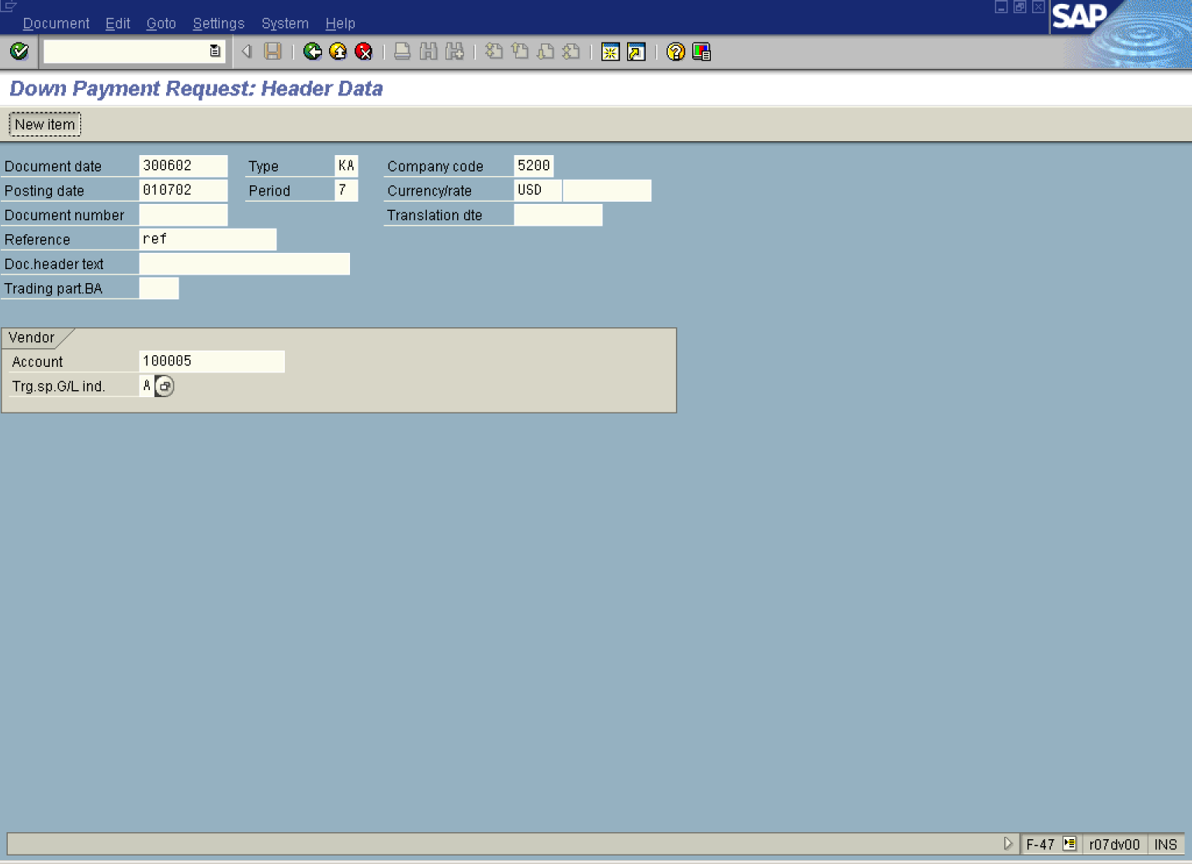

2. Update the following fields:

Field Name | Field Description | Values
Document date | Date the transaction occurred | Example: 300602
Type | Document type | Example: KA
Company code | Code identifying a separate legal entity for which a separate set of accounts is maintained for external reporting purposes | Example: 5200
Posting date | Date that the business transaction occurred | Example: 010702
Currency/rate | Code identifying the currency used in the transaction | Example: USD
Reference | Doc. Description | Example: ref
Account | Vendor account number | Example: 100005
Trg.sp.G/L ind. | Special GL transaction code. You determine the special G/L indicator for a down payment request in this field with which the corresponding down payment is to be posted later. | Example: A

3. Click New item Button to enter Down Payment line item:

Down Payment Request: Add Vendor item

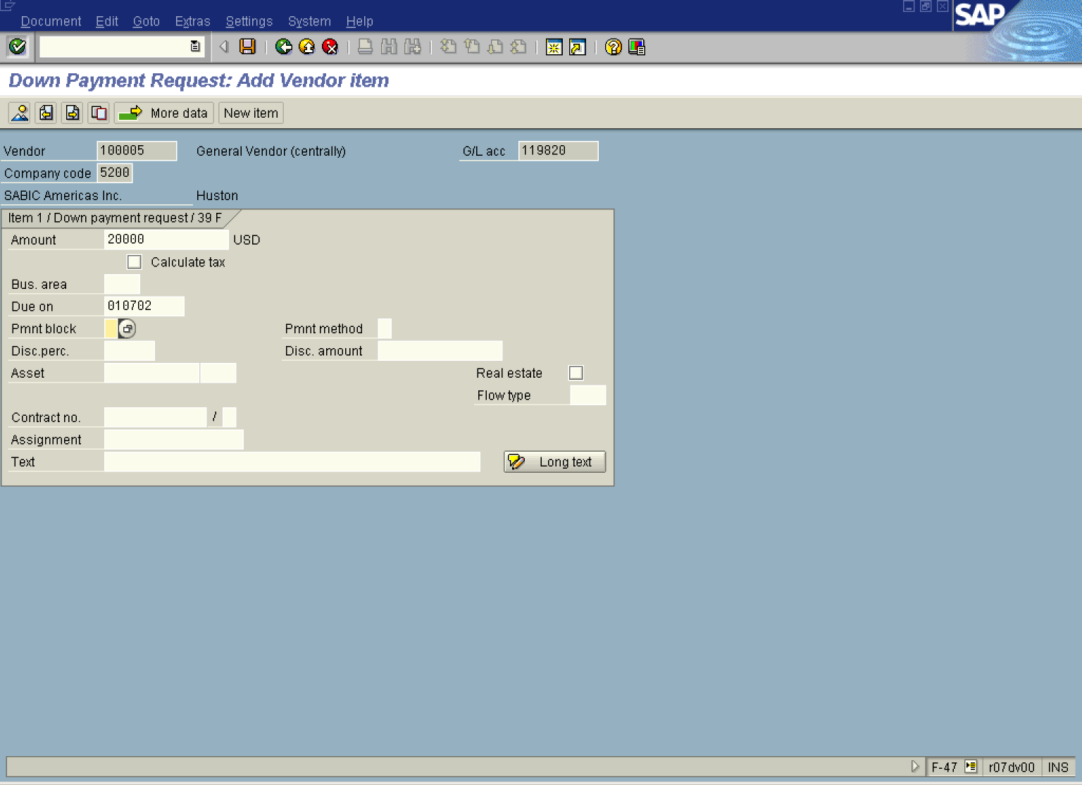

4. Update the following fields:

Field Name | Field Description | Values
Amount | Amount of the line item | Example: 20000
Due on | Date when the down payment is due | Example: 010702

5. Click Enter Button to confirm your entries.
6. Click Overview Button to display a document before posting:

Down Payment Request: Display Overview

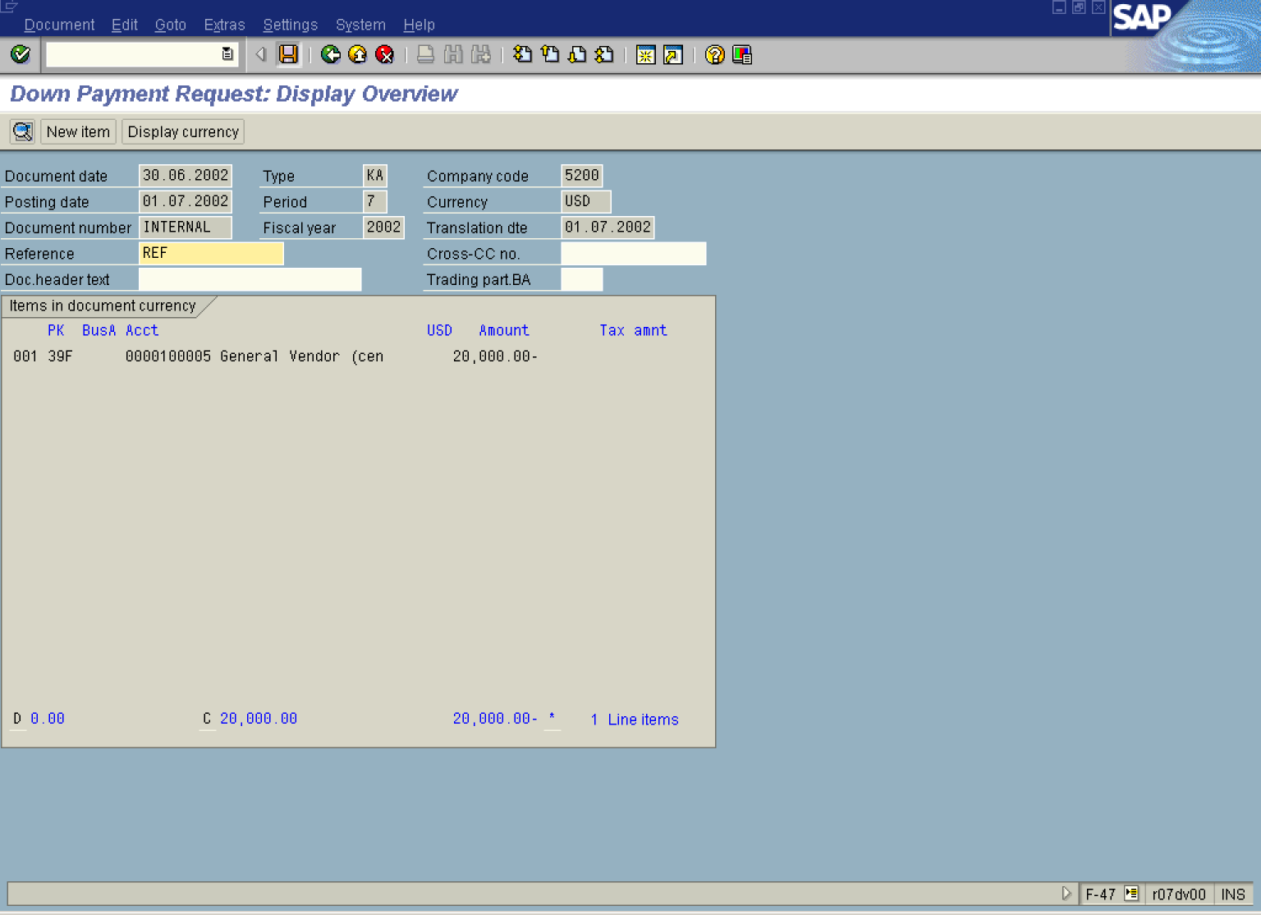
7. Click Save Button. to post the down payment request.

8. The message bar displays ”Document XXXXXXXX was posted in company code 5200”.

